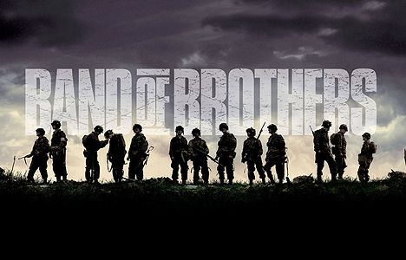

PART I: CURRAHEE

- Why did many men end up joining the newly formed airborne division?

- Where were these men trained initially? What is the name of their company?

- How would you describe Lt. Sobel’s attitude toward his company?

- What year is it? What is the motto of this company?

- Where are they being sent? When do they arrive?

- Discuss how they are being prepared.

- How would you describe Capt. Sobel as a field commander? Give an example.

- Why do you think Sobel tried to censure Winters?

- Why did Winters insist on a court martial?

- How do some of the men of Easy Company respond to Lt. Winters court martial?

- What happened to Captain Sobel?

- What advice does Lt. Winter give Buck Compton about the men of Easy Company?

- What is the code name of this mission?

- Where is Easy Company going to be dropped in France?

- Why is the invasion initially postponed?

- Describe the physical appearance and mental state of the paratroopers as they prepare for their real jump into France.

- What were Gen. Dwight Eisenhower’s parting words?

After viewing: The word “Currahee” is a Cherokee word meaning “stands alone” and a word that became the cry of the 506th Paratroopers Regiment (which included Easy Company). One reason this became a rallying cry for the paratroopers was that they trained at Currrahee Mountain when they were at Camp Toccoa. Beyond that, why might they have chosen a motto “We stand alone, together”? What do you think this meant to the men?

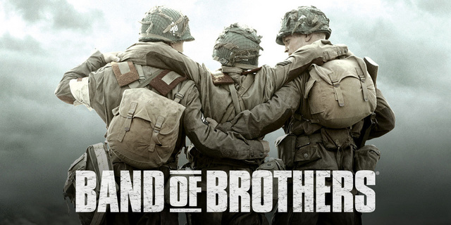

PART II: DAY OF DAYS

- Describe the conditions the paratroopers endured while being dropped over France.

- After the jump, where does Lt Winters end up and how far away are they from their objective?

- Many paratroopers were killed during the jump into France, who is now next in line to become the new commander of Easy Company?

- What did Lieutenant Spiers do to the German prisoners who were captured? Why didn’t any of the G.I.s say anything?

- In this episode, on what D-Day invasion beach are the German artillery shells landing? Why is this a problem?

- During the assault to knock out the German artillery, what did Lt. Winters recover?

- Why didn’t Lt. Winters show much enthusiasm when he learned that the map he had found contained important information about the location of German gun placement throughout Normandy?

- Discuss the promise Lt. Winters makes to himself after that 1st day in Normandy.

- What were the main themes of this episode?

- What award did Lt. Winters receive as a result of his efforts on that day?

- After the allied powers were able to penetrate German defenses on the coast of France, what is their next objective?

After viewing: Why do WW II stories enjoy such widespread popularity in books, movies, and public commemorations? What does this tell us about the war, and what does it tell us about our own times?

