Label the Latitude and Longitude
Using the terms below label latitudes and longitudes on the world map.
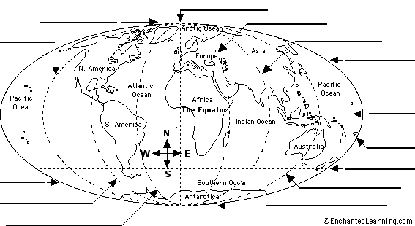

90º N  45º N  0º Latitude  45º S  90º S | 180º W  135º W  90º W  45º W  0º Longitude | 45º E  90º E  135º E  180º E

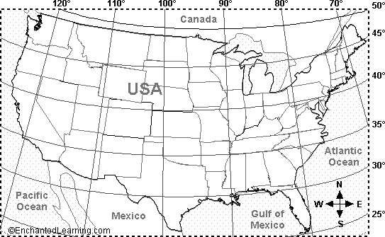

1. Do lines of latitude run east-west or north-south? | _____________________
2. Name three states that extend below latitude 30 degrees N (in the contiguous US), and label them on the map. | _____________________
 | _____________________
 | _____________________
3. Name one US state that is mostly east of longitude 70 degrees W, and label it on the map. | _____________________
4. Name three US states (shown on this map) that extend west of longitude 120 degrees W, and label them on the map. | _____________________
 | _____________________
 | _____________________
5. Is the location 45 degrees N latitude, 82 degrees W longitude on land or under water? On the map, mark it with a red X. | _____________________
6. Name the state that is located entirely between 40-45 degrees N latitude and between 90-100 degrees W longitude, and label it on the map. | _____________________

1. The location 26 degrees N, 105 degrees W is in what country? Mark the spot on the map with a black X. | _____________________
2. Is the location 35 degrees N latitude, 75 degrees W longitude in the Atlantic or Pacific Ocean? Mark it on the map with a green X. | _____________________
3. Is the location 30 degrees N, 87 degrees W on land or under water. Mark it on the map with a blue X. | _____________________
4. On the map, label the location 38 degrees N latitude, 105 degrees W longitude with a red X and write the name of the state it is in. | _____________________
5. The location 43 degrees N, 75 degrees W is in what state? On the map, write the state's name. | _____________________
6. Name the state whose southern border is latitude 35 degrees N, and label the state on the map. | _____________________

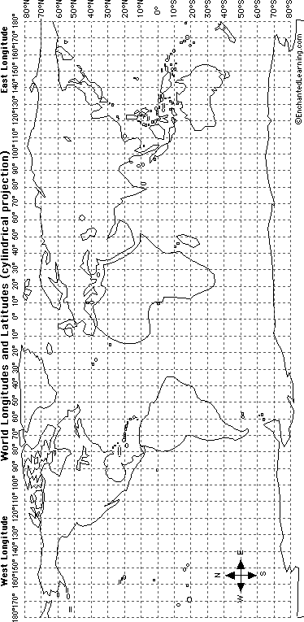
Using the world longitude and latitude map printout, answer the following questions and mark the locations.
1. Draw a red line along the equator (0 degrees latitude).
2. Draw a purple line along the Prime Meridian (0 degrees longitude).
3. In which ocean is the location 10 degrees S latitude, 75 degrees E longitude located? Mark it on the map with a blue "X" and write the name of the ocean.
4. In which ocean is the location 30 degrees N latitude, 60 degrees W longitude located? Mark it on the map with a blue "Y" and write the name of the ocean.
5. Mark the following cities on the map in red:
B. Beijing: 40°N, 116°E
C. Cairo: 30°N, 31°E
CT. Cape Town: 34°S, 18°E
H. Hong Kong: 22°N, 114°E
J. Jakarta: 6°S, 106°E
LA. Los Angeles: 34°N, 118°W
LI. Lima: 12°S, 77°W
LO. London: 51°N, 0°W
MC. Mexico City: 19°N, 99°W
MO. Moscow: 55°N, 37°E
MU. Mumbai: 19°N, 72°E
NA. Nairobi: 1°S, 37°E
NO. New Orleans: 30°N, 90°W
NY. New York: 40°N, 74°W
R, Rio de Janeiro: 23°S, 43°W
SE. Seattle: 47°N, 122°W
SY. Sydney: 34°S, 151°E
TK. Tokyo: 35°N, 139°E

