Chapter 25 Notes:
Section 1 Factors That Affect Climate (A-D)
A: Temperature and Precipitation
climate the average weather conditions in an area over a long period of time
- Climates are chiefly described using average temperature and precipitation.
- Another way scientists describe climate is by using the yearly temperature range, or the difference between the highest and lowest monthly averages.
- The factors that have the greatest influence on both temperature and precipitation are latitude, heat absorption and release, and topography.
B: Latitude → Solar Energy
- The higher the latitude of an area is, the smaller the angle at which the sun’s rays hit Earth is and the smaller the amount of solar energy received by the area is.
- Because Earth’s axis is tilted, the angle at which the sun’s rays hit an area changes as Earth orbits the sun.
Global Wind Patterns
- Because Earth receives different amounts of solar energy at different latitudes, belts of cool, dense air form at latitudes near the poles, while belts of warm, less dense air form near the equator.
- Winds affect many weather conditions, such as precipitation, temperature, and cloud cover.
- Thus, regions that have different global wind belts often have different climates
- As seasons change, the global wind belts shift in a north or south direction.
- As the wind and pressure belts shift, the belts of precipitation associated with them also shift.
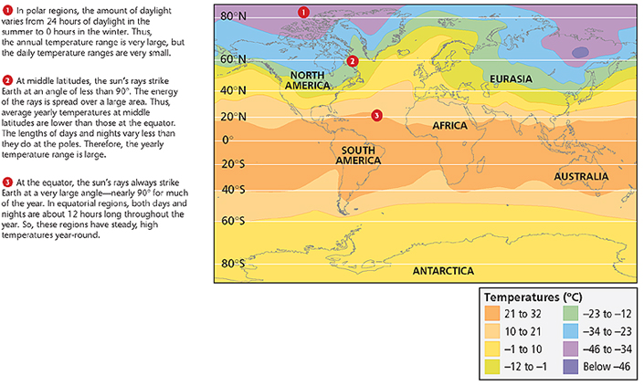

C: Heat Absorption and Release
- Land heats faster than water and thus can reach higher temperatures in the same amount of time.
- Waves, currents, and other movements continuously replace warm surface water with cooler water from the ocean depths.
- In turn, the temperature of the land or ocean influences the amount of heat that the air above the land or ocean absorbs or releases.
- The temperature of the air then affects the climate of the area.
Specific Heat and Evaporation
specific heat the quantity of heat required to raise a unit mass of homogeneous material 1 K or 1°C in a specified way given constant pressure and volume
- Even if not in motion, water warms more slowly than land does.
- Water also releases heat energy more slowly than land does.
- A given mass of water requires more energy than land of the same mass does to experience an increase in temperature of the same number of degrees.
- The average temperature of land and water at the same latitude also vary because of differences in the loss of heat through evaporation.
- Evaporation affects water surfaces much more than it affects land surfaces.

Ocean Currents
- The temperature of ocean currents that come in contact with the air influences the amount of heat absorbed or released by the air.
- If winds consistently blow toward shore, ocean currents have a strong effect on air masses over land.
- For example, the combination of a warm Atlantic current and steady westerly winds gives northwestern Europe a high average temperature for its latitude.

El Niño Southern–Oscillation
El Niño the warm-water phase of the El Niño Southern Oscillation; a periodic occurrence in the eastern Pacific Ocean in which the surface-water temperature becomes unusually warm (ENSO)
- The event changes the interaction of the ocean and the atmosphere, which can change global weather patterns.
- The ENSO also has a cool-water phase called La Niña, which also affects weather patterns.

Seasonal Winds
monsoon a seasonal wind that blows toward the land in the summer, bringing heavy rains, and that blows away from the land in the winter, bringing dry weather
- Temperature differences between the land and the oceans sometimes cause winds to shift seasonally in some regions.
- Monsoon climates, such as that in southern Asia, are caused by heating and cooling of the northern Indian peninsula.

D: Topography
Elevation
- The surface features of the land, or topography, also influences climate.
- The elevation, or height of landforms above sea level, produces distinct temperature changes.
- Temperature generally decreases as elevation increases.
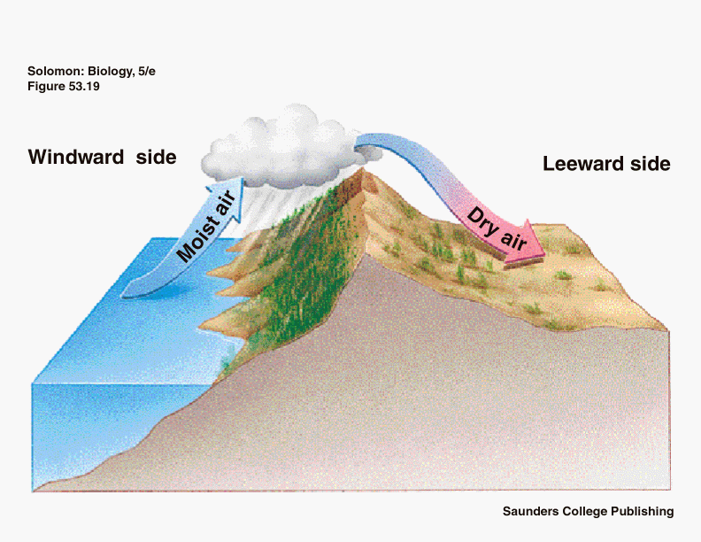
Rain Shadows
- When a moving air mass encounters a mountain range, the air mass rises, cools, and loses most of its moisture through precipitation.
- As a result, the air that flows down the other side of the range is usually warm and dry. This effect is called a rain shadow.
- One type of warm, dry wind that forms in this way is a the foehn (FAYN), a dry wind that flows down the slopes of the Alps.

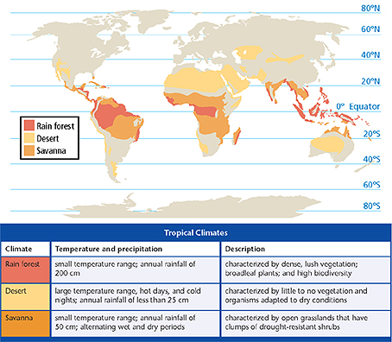
Chpt 25 Section 2 Climate Zones
- Describe the three types of tropical climates.
- Describe the five types of middle-latitude climates.
- Describe the three types of polar climates.
- Explain why city climates may differ from rural climates.

Climate Zone
- Earth has three major types of climate zones: tropical, middle-latitude, and polar.
- Each zone has distinct temperature characteristics, including a specific range of temperatures.
- Each of these zones has several types of climates because the amount of precipitation within each zone varies.

Tropical Climates
tropical climate a climate characterized by high temperatures and heavy precipitation during at least part of the year; typical of equatorial regions
- These climates have an average monthly temperature of at least 18°C, even during the coldest month of the year.
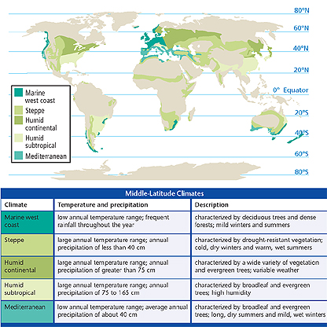
- Within the tropical zone, there are three types of tropical climates: tropical rain forest, tropical desert, and savanna.

Middle-Latitude Climates
middle-latitude climate a climate that has a maximum average temperature of 8°C in the coldest month and a minimum average temperature of 10°C in the warmest month
- There are five middle-latitude climates: marine west coast, steppe, humid continental, humid subtropical, and mediterranean.

Polar Climates
polar climate a climate that is characterized by average temperature that are near or below freezing; typical of polar regions

- There are three types of polar climates: the subarctic climate, the tundra climate, and the polar icecap climate.

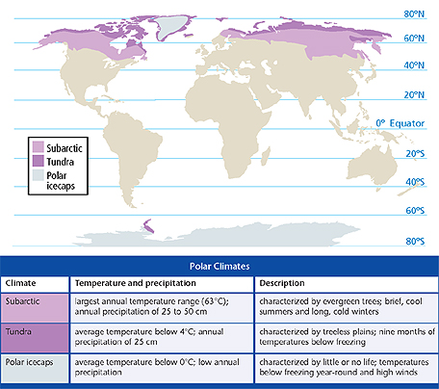
Local Climates
microclimate the climate of a small area
- Microclimates are influenced by density of vegetation, by elevation, and by proximity to large bodies of water.
- For example, in a city, pavement and buildings absorb and reradiate a lot of solar energy, which raises the temperature of the air above and creates a “heat island.”
- In contrast, vegetation in rural areas does not reradiate as much energy, so temperatures in those areas are lower.

Effects of Elevation
- As elevation increases, temperature decreases and the climate changes.
- For example, highland climate is characterized by large variation in temperatures and precipitation over short distances because of changes in elevation.
- Highland climates are commonly located in mountainous regions—even in tropical areas.

Effects of Large Bodies of Water
- Large bodies of waters, such as lakes, influence local climates. The water absorbs and releases heat slower than land does.
- Therefore, microclimates near large bodies of water have a smaller range of temperatures and higher annual precipitation than other locations at the same latitude.

Chapter 25 Section 3 Climate Change
- Compare four methods used to study climate change.
- Describe four factors that may cause climate change.
- Identify potential impacts of climate change.
- Identify ways that humans can minimize their effect on climate change.

Potential Causes of Climate Change
- By studying computer-generated climate models, scientists have determined several potential causes of climate change.
- Factors that might cause climate change include the movement of tectonic plates, changes in the Earth’s orbit, human activity, and atmospheric changes

1- Plate Tectonics
- The movement of continents over millions of years caused by tectonic plate motion may affect climate change.
- The changing position of the continents changes wind flow and ocean currents around the globe.
- These changes affect the temperature and precipitation patterns of the continents and oceans

2- Orbital Changes
- Changes in the shape of Earth’s orbit, changes in Earth’s tile, and the wobble of Earth on its axis can lead to climate changes.
- The combination of these factors is described by the Milankovitch theory.
- Each change of motion has a different effect on climate.
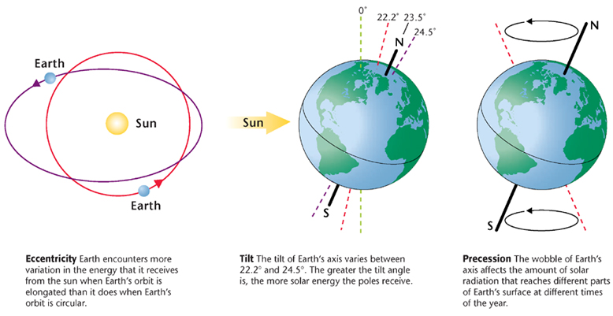

3- Human Activity
- Pollution from transportation and industry releases carbon dioxide, CO₂, into the atmosphere.
- Increases in CO₂ concentration may lead to global warming, an increase in temperatures around the Earth
- Because vegetation uses CO₂ to make food, deforestation also affects one of the natural ways of removing CO₂ from the atmosphere.
- Another significant gas emitted from garbage dumps and agriculture (livestock) is methane. There is not as much methane released as CO₂ - but because each methane molecule has a more significant impact on global warming than CO₂ - it has a significant impact on the greenhouse effect.

4- Volcanic Activity
- Large volcanic eruptions can influence climates around the world.
- Sulfur and ash from eruptions can decrease temperatures by reflecting sunlight back into space.
- These changes last from a few weeks to several years and depend on the strength and duration of the eruption.

Potential Impacts of Climate Change
- Earth’s atmosphere, oceans, and land are all connected, and each influences both local and global climates.
- Even short-term changes in the climate may lead to long-lasting effects that may make the survival of life on Earth more difficult for both humans and other species.
- Some of these potential climate changes include global warming, sea-level changes, and changes in precipitation.

1- Global Warming
global warming a gradual increase in the average global temperature that is due to a higher concentration of gases such as carbon dioxide in the atmosphere
- Global temperatures have increased approximately 1°C over the last 100 year.
- Researchers are trying to determine if this increase is a natural variation or the result of human activities, such as deforestation and pollution.
- An increase in global temperature can lead to an increase in evaporation.
- An increase in global temperatures could also cause ice at the poles to melt.
- If a significant amount of ice melts, sea levels around the world could rise.

2- Sea-Level Changes
- An increase of only a few degrees worldwide could melt the polar icecaps and raise sea level by adding water to the oceans.
- Many coastal inhabitants would be displaced, and freshwater and agricultural land resources will be diminished with the change in sea level.

What Humans Can Do
- Many countries are working together to reduce the potential effects of global warming.
- Treaties and laws have been passed to reduce pollution.
- Even community projects to reform areas have been developed on a local level.

Individual Efforts
- Pollution is caused mostly by the burning of fossil fuels, such as running automobiles and using electricity.
- Therefore, humans can have a significant effect on pollution rates by turning lights off when they are not in use, by turning down the heat in winter, and by reducing air conditioner use in the summer.

Transportation Solutions
- Using public transportation and driving fuel-efficient vehicles help release less CO2 into the atmosphere.
- All vehicles burn fuel more efficiently when they are properly tuned and the tires are properly inflated.
- Car manufacturers have been developing cars that are more fuel efficient. For example, hybrid cars use both electricity and gasoline.

